bunny-borderv.gifbunny-borderv.gif 

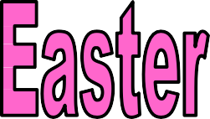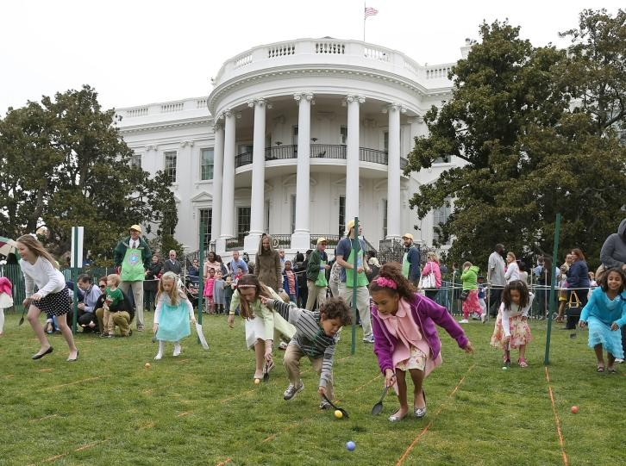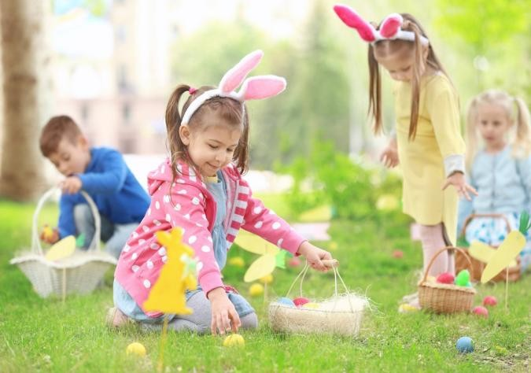

*At Easter, British people sometimes organize egg h……………………… Girls wear b……………………………… and children look for eggs. Their parents h……………………… the eggs at home or in the g……………………………….*

*When the children find the eggs, they put them in a b………………………………. When the children find all the eggs their parents give them a big c egg.*

*Americans at E organize egg r……………………………….*

*The President of the United States invites c…………………………*

*to play a game rolling colored e………………… on the grounds behind the White House.*

*Hundreds of children come with b……………………………… filled with brightly c eggs*

*and roll them down the famous h………………………… The rules of an Easter Egg Roll are to see who can roll an egg the greatest distance or who can make the roll without breaking it, down a grassy hill.*

***hide, chocolate, garden, bonnets, basket, hunts***

***decorated, rolling, hill, Easter eggs, baskets,***



**Complete the texts with the words from the boxes**

Maestralidia.com

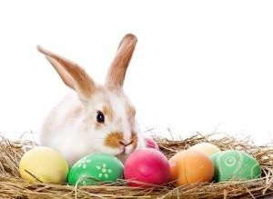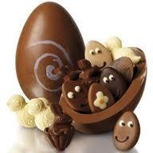

In the UK, we celebrate Easter during Spring. It is a joyful time where people celebrate the rebirth of Jesus. At Easter, Christians go to Church and sing religious songs called ‘hymns’. It is also a time where people share chocolate eggs – called ‘Easter eggs’ – and give them to children. Read at UK traditions associated with Easter.

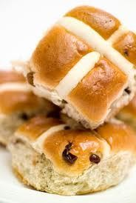

# Hot cross buns

A hot cross bun is a piece of spiced bun which contains raisins and has a cross on the top of it. It is traditionally eaten during Easter. Some English people toast it and then spread butter on it. It is very tasty and sweet.

1. Easter Eggs and The Easter Bunny Easter eggs are a popular item during Easter, especially for children. These are chocolate eggs that are often given out and eaten. Some children in the UK believe that the Easter Bunny brings along chocolate eggs for them. A ‘Bunny’ is another name for a cute and small rabbit. There is usually a game where children hunt for these

chocolate eggs in their garden and put them in a small bag for them to eat later – this is called the Easter Egg Hunt!

# Easter Flowers

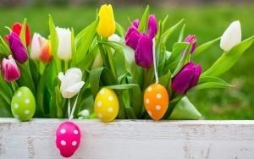

During Easter in the UK, some people buy very colourful flowers to decorate their home. These flowers are considered ‘Easter flowers’.

1. **Painting Eggs** The decorating of coloured eggs is also a very popular activity during Easter. Usually chicken eggs are hard boiled and painted. These are often used in Easter egg hunts along with chocolate Easter eggs. The eggs come

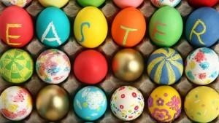

out looking fantastic and magical and add a sense of fun to this springtime holiday

Easter is a big celebration in the UK and is very much part of UK culture with children being given lots of Easter eggs, hunting for sweets left by the Easter bunny and attending church services on the Easter weekend. You will have a chance to buy some Easter eggs in various supermarkets and shops.

What celebrations do you have in your country?

Do you celebrate them with the giving of chocolate?

Do you paint eggs in your country? Have a wonderful Easter. **Maestralidia.com**