

My day

# What’s the word?

Write the word under the pictures.

|  |  |  |  |
| --- | --- | --- | --- |
| ~~have breakfast~~ | television | have lunch | sleep |
| sofa | garden | have dinner | walk |

|  |  |  |  |
| --- | --- | --- | --- |
|  |  |  |  |
|  | have breakfast |  |  |
|  |  |  |  |
|  |  |  |  |

# Read and circle!

Tom is a cat. Read about his usual day and circle the examples of the top tips.

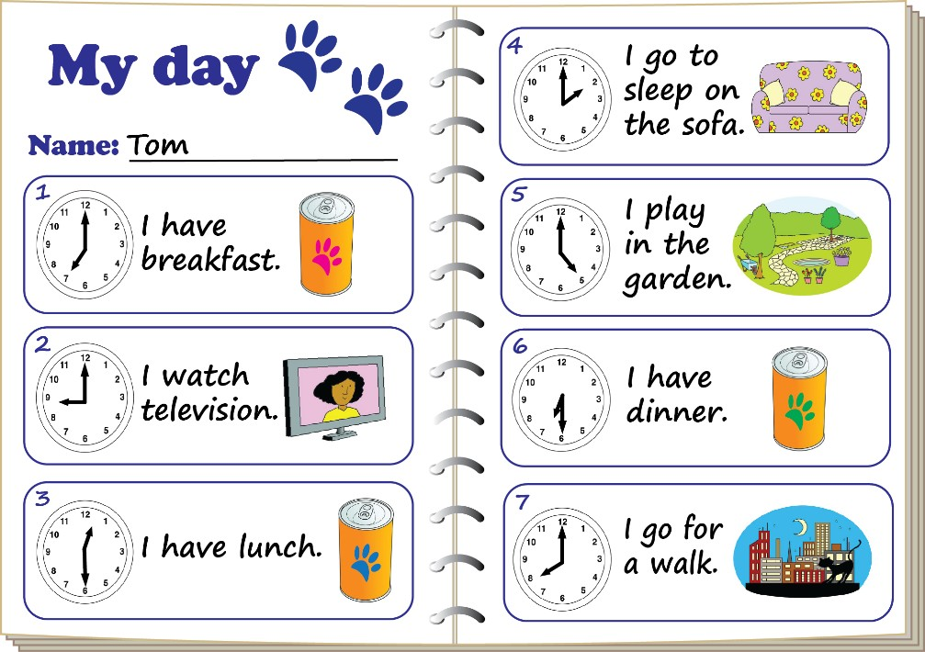

Top tips for writing about your usual day!

1. Start each sentence with a capital ‘I’.
2. Use verbs to say what you do, for example ‘go’, ‘have’, ‘eat’ or ‘play’.
3. Finish each sentence with a full stop.

[www.britishcouncil.org/learnenglishkids](http://www.britishcouncil.org/learnenglishkids)

© British Council, 2016 The United Kingdom’s international organisation for educational opportunities and cultural relations. We are registered in England as a charity.



# What’s the order?

Put the words in the correct order.

1. ~~have~~ ~~breakfast~~. I I have breakfast.
2. watch I television.
3. lunch. have I
4. sleep. I to go
5. in garden. play I the
6. I dinner. have
7. go a I for walk.

# Practise writing!

Write the activities you do. Draw the times on the clocks. Draw a picture for each activity.

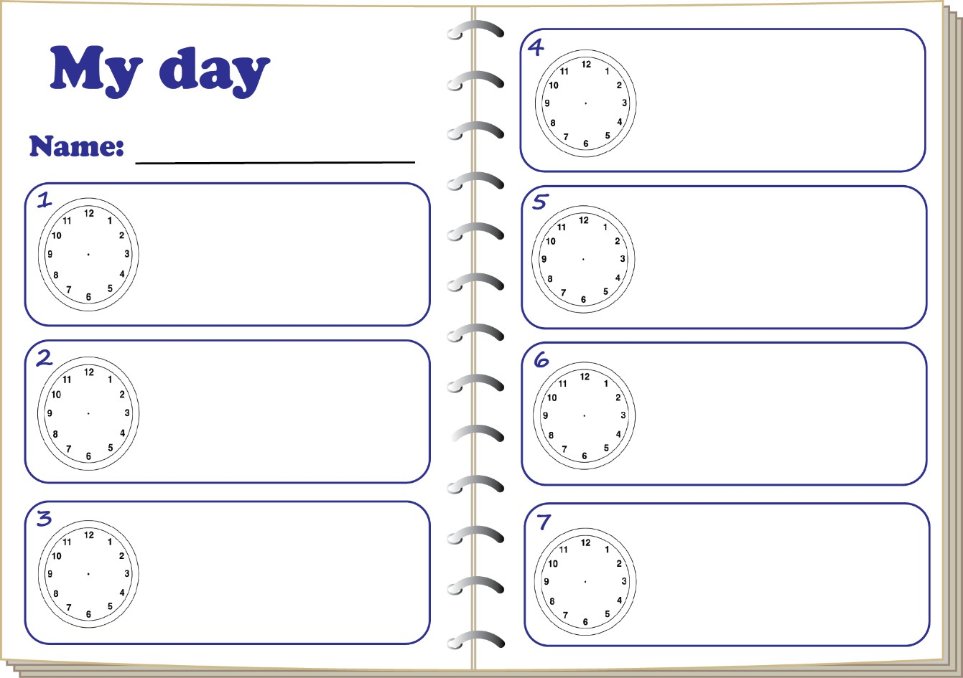

[www.britishcouncil.org/learnenglishkids](http://www.britishcouncil.org/learnenglishkids)

© British Council, 2016 The United Kingdom’s international organisation for educational opportunities and cultural relations. We are registered in England as a charity.