**DESCRIBE YOUR BEDROOM**

1. **Read the description of this bedroom:**

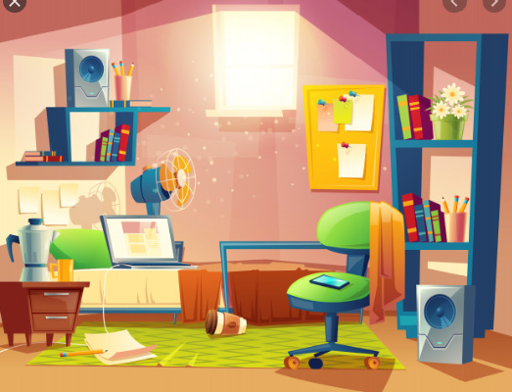

HI! I am Tom and this is my bedroom.

There is a chair next to the radio.

There is a big bed and there is a bedside table next to the bed.

There is a laptop on the bed.

There is a fan next to the laptop.

There are six books in the bookcase and there is a plant on one shelf.

There is notebook and a pencil on the carpet but there isn’t a pencil case.

There is a big window behind the bed.

There is a green chair in front of the bed and there is an orange blanket on the chair.

I can study, read and play there. I love my bedroom!

AND

BUT

Prepositions: on, under, in next to, behind, opposite, in front of, between, near.

**Recuerda:**

Use:

There is (Hay 1)

There are (Hay más de uno)

1. **Draw a picture of your bedroom.**
2. **Write a description of your bedroom:**

___________________________________________________________________________________________________________________________________________________________________________________________________________________________________________________________________________________________________________________________________________________________________________________________________________________________________________________________________________________________________________________________________________________________________________________________________________________________________________________________________________________________________________________________________________________________________________________________________________________________________________________________________________________________________________________________________________________________